2015-CZ-01-EN Walnut animals
0 hard | I: hard | II: medium | III: easy | IV: easy

Answer Type: Interactive Graphics are: used with permission and colorblind proof

Body
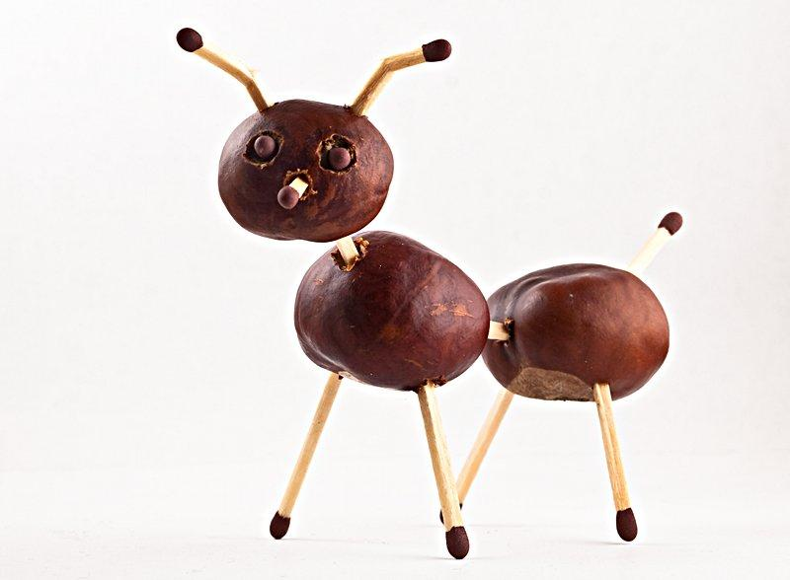

A beaver was inspired by the picture of an animal made from nuts, and created 4 animals by himself using walnuts, strings and glue:

Starfish | Dog | Sea lion | Giraffe
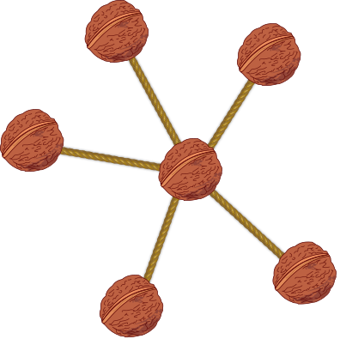 | 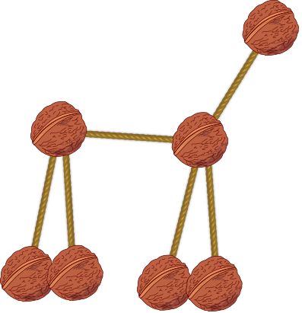 | 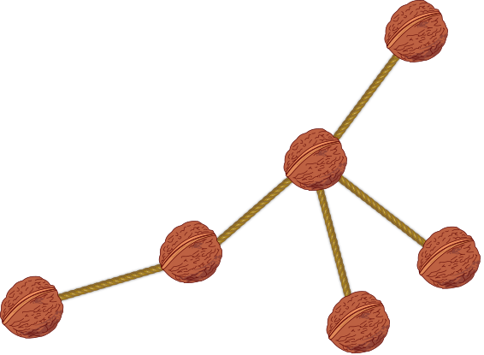 | 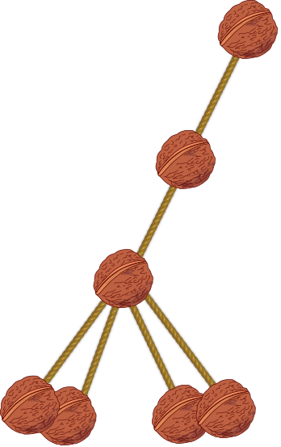

His sister played with these animals and transformed them in the way that it became difficult to recognize what was what.

Question

Drag transformed animals to the originals.

Answer

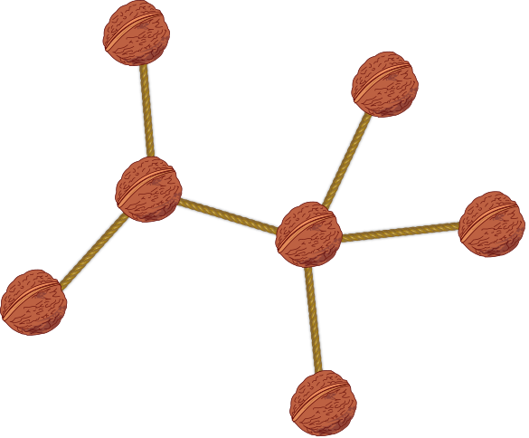 | 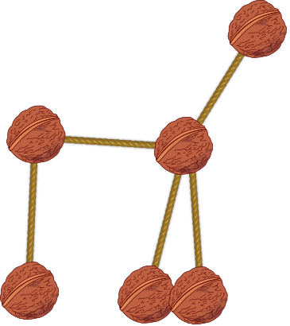 | 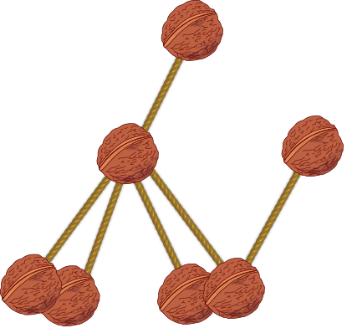 | 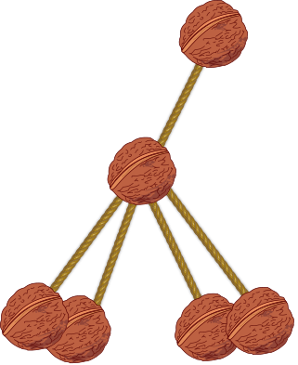

Explanation

Each animal is determined by the connections between its parts. The specific positions of parts and angles of connections may change during the dance, but that does not change the animal itself. So we need to determine pairs of pictures with the same structure on them.
Let's start with the starfish. It has a regular structure and is therefore easiest to spot: one central part and five arms. There is only one possibility among transformed animals:
The giraffe is quite like a starfish, except for that one arm is longer, it is the neck with the head. So we search for an animal with four short legs, one longer neck, all attached to one part, the body.
The sea lion is also similar, but one of the short pieces is missing, so the central part only has four connections.
Last remaining is the dog. It has seven parts and none of them is clearly central.

It's informatics

With walnut animals, we abstract from features like fur and size. We represent the animal only by the structure of its body, the rest is unimportant. This structure is preserved even when the animals are transformed. A computer scientist must recognize what is important, what can be left out, and how are two structures similar.
If the animals in our task were just a bit bigger and more complicated, it would be extremely difficult to identify them. That is why computer scientists try to invent efficient algorithms to solve such problems.

Keywords

Graph theory, isomorphism

Websites

http://en.wikipedia.org/wiki/Graph_theory
http://g.ivank.net/
http://en.wikipedia.org/wiki/Graph_isomorphism

Internal Use

Wording

Animal, walnut, transforming

Comments

Author, e-mail, Date (YYYY-MM-DD), Comment.

Dan Lessner, 2015-04-10. All the animals have 6 or 7 chestnuts and no cycles, otherwise it would be too easy. The dancing positions are intentionally resembling other animals when possible.

Ilya Posov and Simona Feiferyte, 2015-05-27, here is the original comment of the author about possible answer types:

Interactivity: Kids will drag each transformed animal and drop it over the correct same animal in basic position. The system could recognize the correct solution automatically, but this is not necessary.
Not-interactive: Number of simple modifications: multiple choice with animal orders (ACBD, BDCA, …), showing four pairs and searching for the incorrect one, having one transformed animal and choosing which one it is (or the other way round, “which of the dancing animals is the dog, as seen on this basic picture”).

Ilya Posov and Simona Feiferyte, 2015-05-27, here is one more original author comment moved from the wording section:

The task relies on an intuitive idea of sameness of the animal, i.e. the only possible changes are the angles and positions of “bones and joints”. Any other change (new joint...) should result into some different animal in kids minds.
The task can probably be used only in countries where chestnuts grow and creating animals is a common activity. Otherwise, I don't know, marshmallows?

Ilya Posov and Simona Feiferyte, 2015-05-27, the concept of dancing animal was great, but we think it did not really explain what was going on. So we changed it to more boring version about a sister. We also changed graphics.

Ilya Posov and Simona Feiferyte, 2015-05-28, one may remove the image of a chestnut animal and the first part of the statement, this will make the statement shorter.

Graphics
The photograph is from http://commons.wikimedia.org/wiki/File:Chestnut_animal.jpg
It would be great to find one in the style used in the task – a chestnut for each foot, no ears etc., really just the “graph” of the animal.
Walnut and rope are taken from openclipart:
https://openclipart.org/detail/204874/walnut-colored
https://openclipart.org/detail/172158/rope

Files

All additional files for this task (graphics, scripts, etc.)
2015-CZ-01-EN.odt (this file)
2015-CZ-01-EN.svg (inkscape sources)

2015-CZ-01-EN.svg all the animals
Chestnut_animal.jpg illustrative photo
2015-CZ-01-EN_dog.png single animals, “_d” is dancing version
2015-CZ-01-EN_dog_d. png
2015-CZ-01-EN_giraffe. png
2015-CZ-01-EN_giraffe_d. png
2015-CZ-01-EN_sealion. png
2015-CZ-01-EN_sealion_d. png
2015-CZ-01-EN_starfish.png
2015-CZ-01-EN_starfish_d. png
convertGraphics.bash simple script to export vectors to PNG

Authorship

Dan Lessner, lessner@ksvi.mff.cuni.cz, Czechia

License

Copyright © 2014 Bebras – International Contest on Informatics and Computer Fluency. This work is licensed under a Creative Commons Attribution-NonCommercial-ShareAlike 3.0 Unported License (CC BY-NC-SA 3.0). Visit: http://creativecommons.org/licenses/by-sa-sa/3.0/

